**C**

**H**

**A**

**P**

**T**

**E**

**R**

**-**

**1**

**I**

**N**

**T**

**R**

**O**

**D**

**U**

**C**

**T**

**I**

**O**

**N**

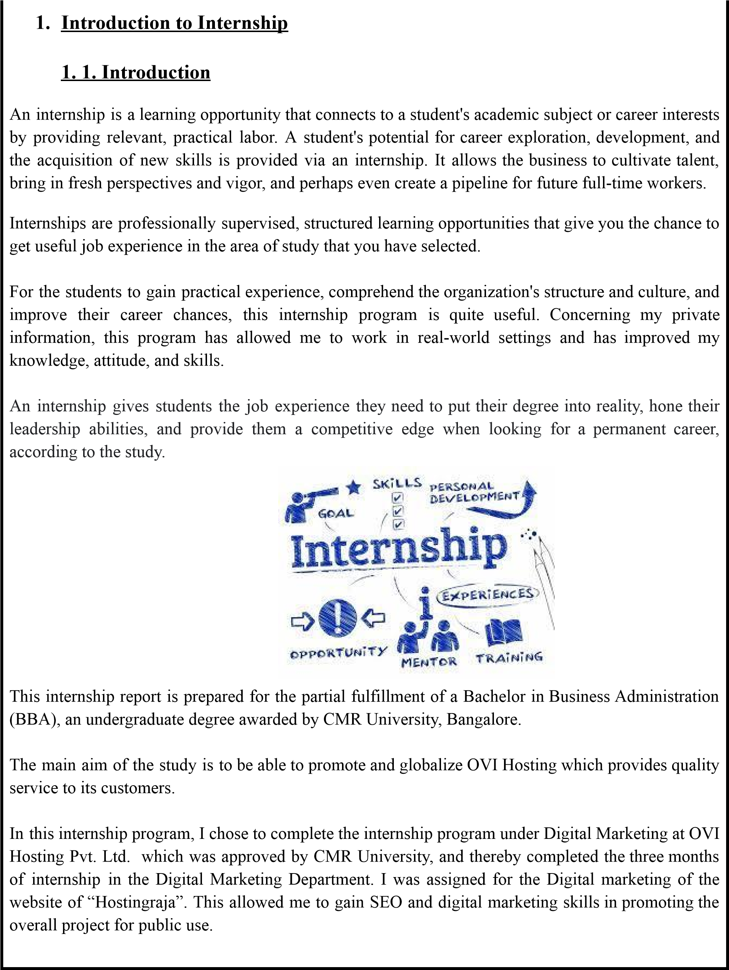

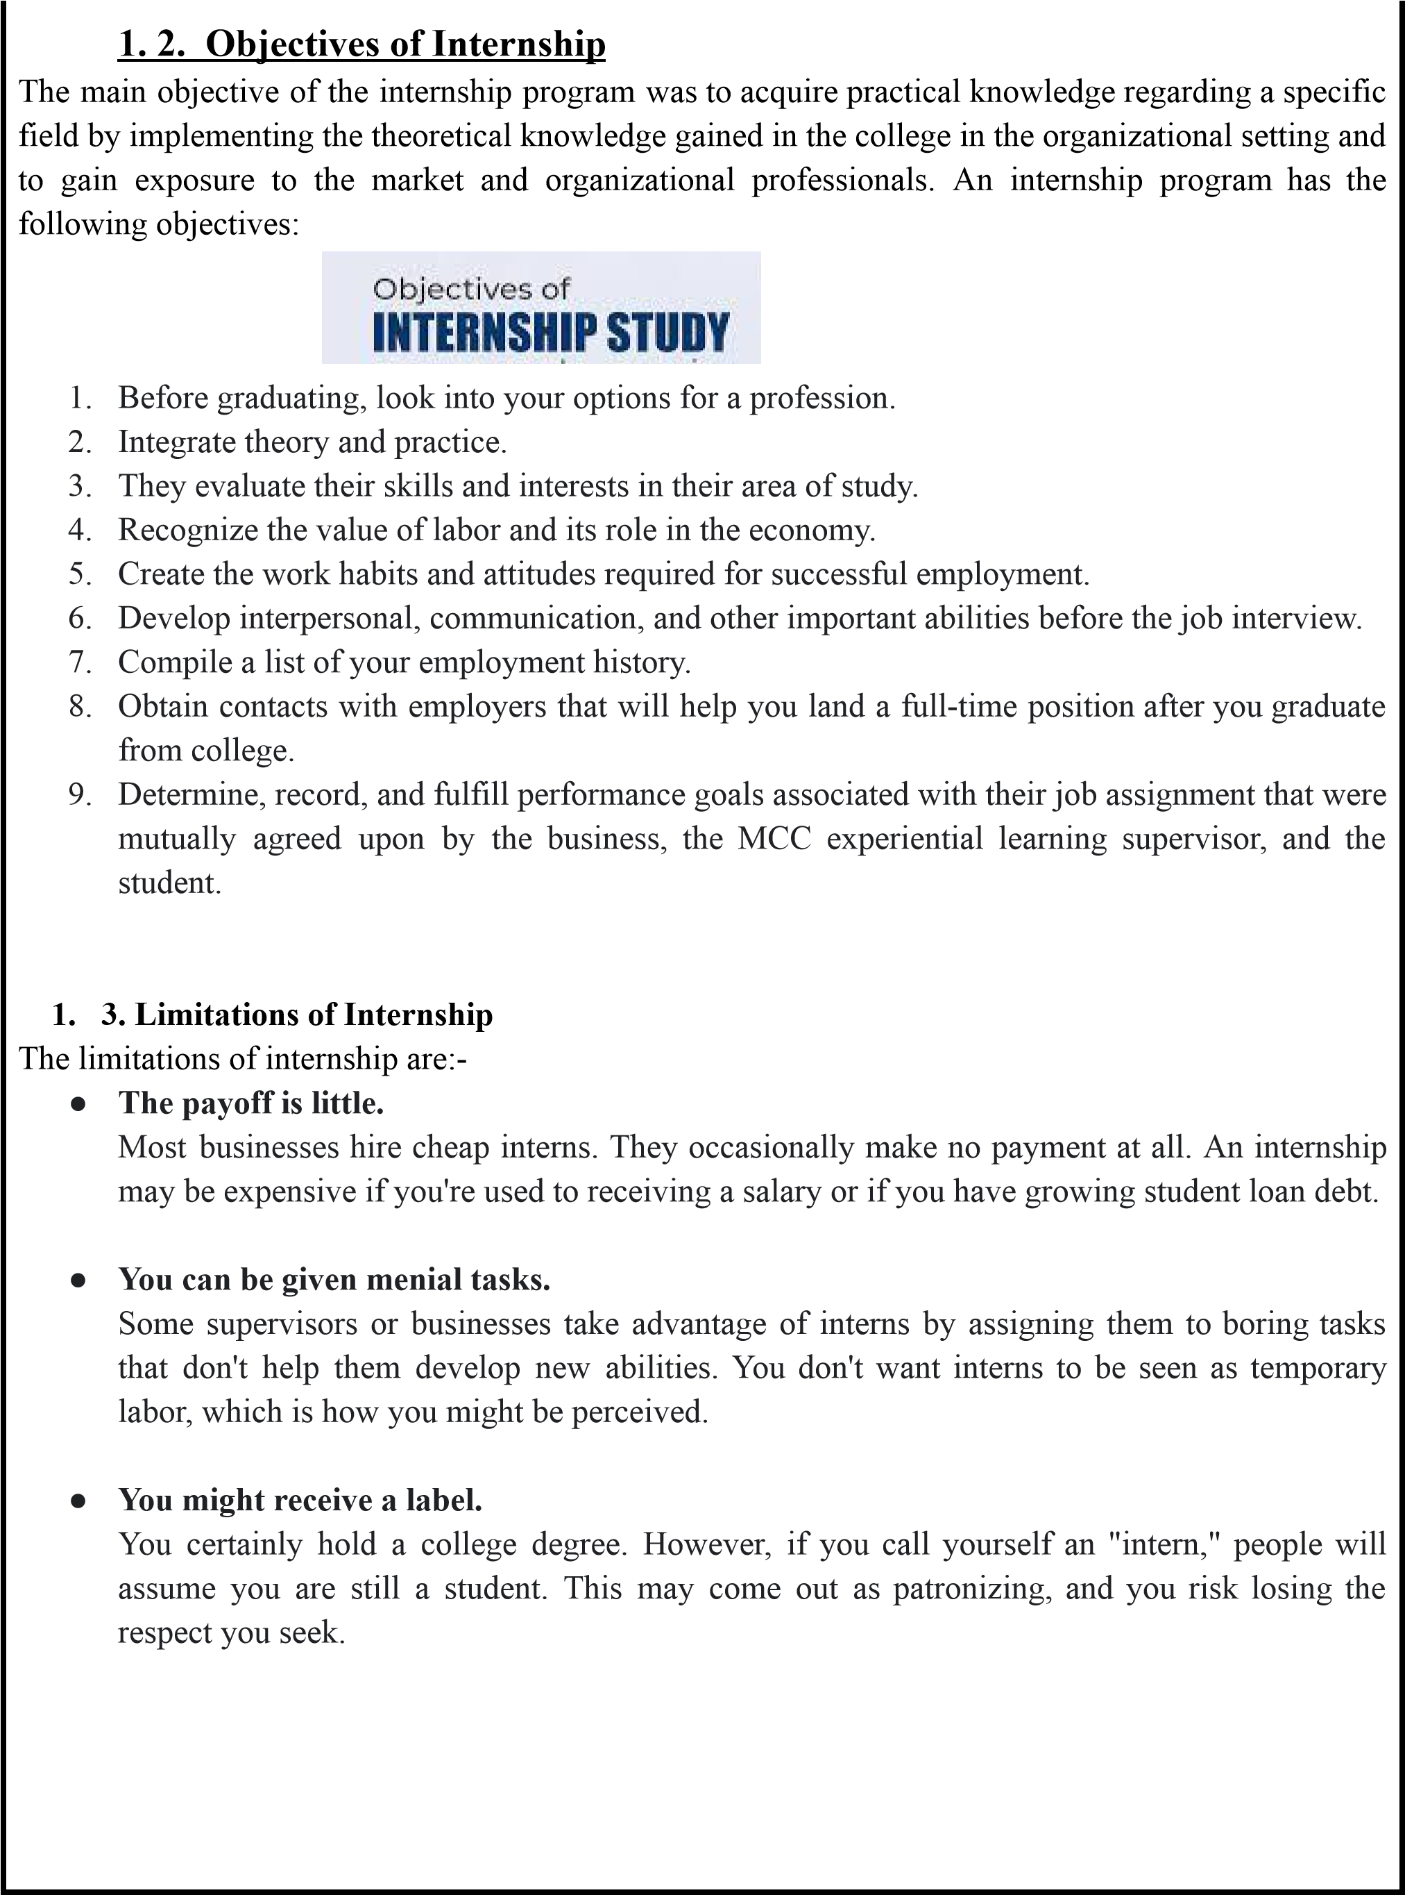

**C**

**H**

**A**

**P**

**T**

**E**

**R**

**-**

**2**

**I**

**N**

**D**

**U**

**S**

**T**

**R**

**Y**

**P**

**R**

**O**

**F**

**I**

**L**

**E**

**&**

**C**

**O**

**M**

**P**

**A**

**N**

**Y**

**P**

**R**

**O**

**F**

**I**

**L**

**E**

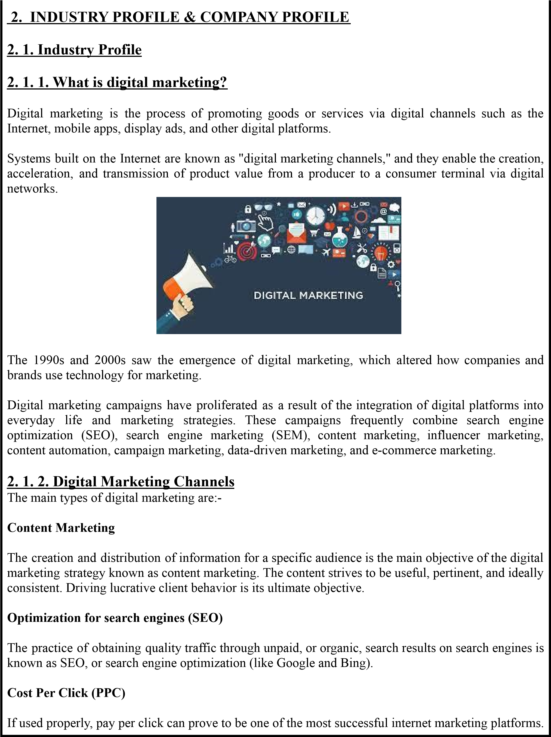

PPC aims to convert latent users into interested prospects who can then be converted into customers.

**Email Marketing**

Email

provides

a

far

more

intimate

means

of

communicating

with

your

tar

get

audience.

This

kind

of

internet marketing can really help you stand out from the crowd.

**Social media Marketing**

One

of

the

most

ef

fective

internet

marketing

platforms

available

today

is

social

media.

A

space

for

dynamic

two-way

communication

is

provided

through

platforms

like

Facebook,

Instagram,

Y

ouT

ube,

T

witter

, etc.

**V**

**ideo**

**Advertising**

One

of

the

most

engaging

and

engaging

forms

of

online

marketing

is

video

advertising.

It

comprises

internet

display

advertisements

with

embedded

videos.

These

commercials

may

also

play

before

to,

during,

or

following

a

video

These

commercials

may

also

play

before

to,

during,

or

following

a

video

stream.

**Community Marketing**

A

branch

of

social

media

marketing

called

network

marketing

makes

use

of

the

associations

and

groups

that

are

already

active

online.

Finding

a

group

of

specialists,

wholesalers,

or

influencers

who

can inform your tar

get market about your company is the key

.

**Relevant Marketing**

It

serves

as

both

advertising

and

a

tool

for

enhancing

brand

perception.

In

this

case,

the

marketer

wants to grow the company without being picky about the media employed.

**Affiliate Pr**

**omotion**

Online

merchants

can

persuade

additional

merchants

to

sell

their

goods

and

services.

This

practice

of

a

firm

of

fering

another's

goods

as

a

complement

to

its

own

or

as

part

of

a

package

deal

is

known

as

af

filiate marketing.



# 2.1.3. What is Directory Submission

"Directory Submission" is the process of submitting your website URL to various web directories (websites) with the aim of building backlinks and thus increasing business growth. This off-page SEO strategy is utilized to build external links to your website.

One of the best methods for growing the popularity of your website online is directory submission. It is a crucial action made by marketers to raise a website's link reputation. This fantastic technique helps to acquire high-quality one-way backlinks, which are essential to an SEO approach. The quality of the incoming links greatly improves our site's search engine rankings and online exposure. To put it in another way, directory submission is merely a description of how to submit our website to a web directory.



**There are three different categories of directory submissions:**

**Paid or Featured Web Listing:**

In this case, the directory site's owner will charge for submission, and your link will be approved shortly after or within 24 hours. As a result, you will gain backlinks from this kind of submission.

This package is available on some websites for a year or forever.

**Free or regular web listing:**

Over here, the Directory submission is free. There are no fees associated with free or routine submission, however, there is no assurance that the Administrator will approve the websites.

Additionally, this takes time.

**Reciprocal Regular Web Listing:**

When you activate Directory Link, a reciprocal link needs to be supplied to your website. The

Directory administrator will only approve your link at that point.

# 2.1.4 What is Content Management System? (CMS)

A content management system (commonly abbreviated as CMS) is software that enables non-technical individuals to create, administer, and alter material on websites.

A content management system, to put it simply, is a technology that enables you to create a website without having to create all of the codings from start (or even know how to code at all).

**Examples of Popular**

**Content Management Systems.**

Some examples of popular content management systems are

●

W

ordPress

●

Joomla

●

Drupal

●

Magento (for eCommerce stores).

●

Squarespace

●

W

ix

●

TYPO3

**How to Build a**

**W**

**ebsite with a Content Management System**

The general process of building a website with CMS is:

●

Purchase web hosting as well as a domain name.

●

Install your content management system of choice on your web server

.

●

Configure the content management system to dictate how your site looks and functions.

●

Start writing content using the content management system’

s interface.

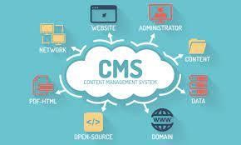

**2**

**. 2. COMP**

**ANY**

**PROFILE**

**2**

**. 2. 1.**

**About us - OVI Hosting Pvt Ltd**

OVI

Hosting

PVT

L

TD

came

into

existence

in

the

year

2015

and

has,

since

then,

been

a

known

name

in

its

field.

The

director

of

Ovi

Hosting

Private

Limited

is

Dhanasekar

Mani

and

Shweta

Shetty

.

Their

expertise

in

Internet

Marketing,

technology

,

and

innovative

sales

techniques

have

enabled

the

successful execution of many strategies @ OVI Hosting.

It is classified as a Non-govt company and is registered at the Registrar of Companies, Bangalore.

Its registered of

fice is in Bangalore, Karnataka, India.

The 2 Directors associated with this or

ganization are Shweta Shetty and Mani Dhanasekar

.

They

have

a

dedicated

team

of

people

to

provide

the

best

quality

service

for

all

their

customers.

W

e

provide various hosting services with domains all over India.

OVI Hosting Pvt. Ltd. is the parent company and has three brands under them, they are:

●

HostingRaja

●

OVI Panel

●

OVI Cloud

●

W

eb bazaar

●

**HostingRaja**

Hostingraja is the leading hosting provider In India which is 10 + years old.

It is one of the fastest-growing companies in India.

It

provides

cheap

and

best-shared

hosting

to

all

Indian

customers

with

quality

customer

support.

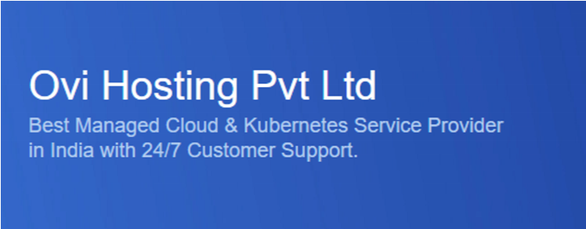

We not only give you web hosting service, but we are always eager in extending our technical expertise in this field so as to help in achieving the goals with ease. Our plans are affordable and come with many features. We have the top packages which use both Windows and

Linux-based systems and it constitutes the required infrastructure and technical expertise.

We have a dedicated team of Engineers giving the [best](https://www.hostingraja.in/) [Indian](https://www.hostingraja.in/) [hosting](https://www.hostingraja.in/) [services](https://www.hostingraja.in/) and working round the clock making sure we provide an uptime of 99.9%, which is extremely rare if you choose any other provider. Moreover, 24/7 customer and technical support are provided by our qualified team of experts.

**● Web bazaar**

Web Bazaar designs develops, hosts & maintains affordable hand-crafted websites for small businesses.

It is a one-stop shop for small businesses to get online. Its extensive template library, a network of in-house designers, and specially designed and hosted content management framework make it a convenient and economic way to manage the online presence of small businesses. Domain registrations and Email accounts are bundled with every package for convenience.



Web Bazaar has served close to 1500 satisfied customers and counting. With its Content Management System-based solution Web Bazaar attempts to bring its expertise to the use of small businesses in an economic fashion and become an enabling factor in India's online growth.

Web Bazaar is a company with the vision of taking businesses online, at a very affordable cost. Web Bazaar offers a whole gamut of features to make the website owners self-sufficient, give them international visibility and help them showcase their products online.

With millions of people using the internet to search for products and services, the internet has become the information superhighway. With adequate information, it may prove to be the marketing strategy that generates the highest return on investment. A web presence can help a business to penetrate new geographies. Web Bazaar aims at enabling its customers to use its web presence as a second shop.

Web Bazaar has a dedicated team of extremely talented, customer-focused, and diligent

individuals

having

a

diversified

skill

set.

The

teams

at

W

eb

Bazaar

abide

by

stringent

quality

standards

and

tailor

their

processes

to

provide

state-of-the-art

services

to

its

customers.

Our

transparent,

ef

ficient,

and

flexible

processes

help

us

create

software

solutions

that

meet

present

as well as future demands.

●

**OVI Cloud**

It is the fastest cloud hosting provider with 7+ years of cloud hosting experience.

Cloud

hosting

makes

applications

and

sites

open

by

utilizing

cloud

resources.

Unlike

standard

hosting,

a

grid

of

connected

virtual

and

physical

cloud

servers

hosts

the

application

or

website,

guaranteeing

more

excellent

flexibility

and

versatility

.

As

HostingRaja

is

one

of

the

leading

cloud

hosting

service

providers

in

India

there

will

be

no

limitations

on

the

number

of

email

accounts or the site hosted by us.

**2**

**.**

**2**

**.**

**2**

**.**

**T**

**h**

**e**

**i**

**r**

**T**

**e**

**a**

**m**

**Dhanasekar**

**Mani**

Founder & CEO

●

MCA

from Madurai University with 16 years of experience in software development, he

worked for 7 years in Samsung where he guided many patented technologies before he

embarked on his entrepreneurial journey

.

●

Mani has a dynamic personality with a go-getter attitude. He is always brimming with ideas

and executing them simultaneously

.

●

His expertise in Internet Marketing, technology

, and innovative sales techniques have enabled

the successful execution of many strategies @ OVI Hosting.



**Shweta Shetty**

Co-Founder COO

●

Shweta has an M.Com, LLB from Mumbai University

, and a PGDBA

from St. Joseph’

s

College, Bangalore, and in an overall experience of 13 years.

●

Her highly ‘process-oriented approach’

towards customer service, management, and operations

has helped create scalable models across the or

g.

●

She is best characterized by her unique approach to leadership and team management. Prior to

OVI, she held sales positions at HDFC & ICICI Bank, Mumbai.

**2**

**.**

**2**

**.**

**3**

**.**

**K**

**e**

**y**

**S**

**e**

**r**

**v**

**i**

**c**

**e**

**s**

**●**

**Shar**

**ed hosting**

Shared Hosting is one of the most booming hosting packages because it comes at a reasonable

price for all the users to get their website online. Shared Hosting operates by letting multiple

users share space on a single server managed by us.

A

[Shared Hosting pla](https://www.hostingraja.in/hosting)

[n](https://www.hostingraja.in/hosting)

contains various

of

fers or mixtures of various features as of

fered by us. HostingRaja delivers the fastest and

most secured servers.

And shared Hosting is perfect for blogging, travel, games, sports, and

small business websites.

**Shar**

**ed Hosting Featur**

**es**



* **Free SSL Certificate** - With SSL Certificate your website is secured and customers trust your website by this sales or revenue will increase. Also, this will make your website search engine friendly.
* **CSS/Js Optimizer –** We provide a WP plugin preinstalled to optimize your CSS and JS files, and guarantee that your website is having 2 CSS and Js files.
* **Modern Security –** We have hardened the features for your website in more than 10+ ways.
* **Divi Themes –** We provide 100s of high-quality WordPress themes and it is available for all the plans.
* **Setup and Installation –** All the above WordPress plans come with ready-to-use preinstalled and detailed guidelines on how to get started.
* **Real-Time Malware Scan –** This is one of the uncommon features available with our WordPress packages which is not open with other service providers.
* **Unlimited SSD Disk Space –** You can any business, personal or official website, blog website without the anxiety of running out of disk space. Also, we have a fair policy for the usage to avoid anyone abusing the servers.
* **One-click Staging –** You can migrate your website using your source code from your development version or staging server to the production server.
* **LightSpeed Web Server –** HostingRaja provide the world’s fastest webserver to deliver your website with a cache option to ensure 5x speed your website.
* **Multiple PHP Version Support –** We provide versions of PHP to support your WordPress website.
* **Easy Drag-n-Drop Website Builder –** A smart-design editor for beginners and pros that simplifies website building. Quick-smart templates, custom CSS, stock image library, mobile editing, and more additional to help you create stunning websites.
* **Automatic WordPress Installation –** Upon creation of your WordPress Hosting plan, HostingRaja automatically installs the latest and most secure version of WordPress.
* **Super Cache Plugin for WP –** In WordPress library holds enormous Cache available to speed your website. By default, we install some of the best plugins.
* **Free Themes & Secure Plugins –** WordPress library has a collection of quality & secure plugins.
* **Free Website Optimization –** When you meet the 90% and above Google page speed score, You can reach our technical team, We will help you with Website Optimization.

**●**

**VPS Hosting**

[V](https://www.hostingraja.in/server/vps-servers)

[irtual Private Serve](https://www.hostingraja.in/server/vps-servers)

[r](https://www.hostingraja.in/server/vps-servers)

hosting, aka

VPS hosting, is

a kind of hosting suited for people who

have grown too big for shared hosting, where users can reside multiple websites on a single

web server

.

VPS hosting is a website hosting atmosphere that allows for devices such as RAM

and CPU to be dedicated to your account. HostingRaja utilizes the best virtualization medium

such as KVM, and

VMW

are for Linux.

This permits for more significant stability and

execution of your website.

**VPS Hosting servers featur**

**es:**

●

**Extendable SSDs –**

W

e provide extra storage for

VPS

Server based on customers’

requests.

●

**Spamassassin with every**

**VPS –**

All your emails are

scanned for protection.

●

**Full r**

**oot/ssh –**

T

otal control over the servers including

reinstall/reboot.

●

**Malwar**

**e Injection –**

Defend your server from viruses

&

Threads.

●

**PHP**

**V**

**ulnerability Check –**

A

unique method to defend

your PHP

files.

●

**Default CSS/JS optimizer**

**–**

Our servers are designed

to be faster for compressing files.

●

**Fr**

**ee SSL**

**Certificate –**

It is really important to secure

your website with SSL.

●

**Near**

**-**

**Instant Pr**

**ovisioning –**

Unlike many

V

irtual Server

hosting service providers in India,

we don’

t char

ge any setup fee.

●

**Uptime Guaranteed –**

W

e pledge 99.99% uptime with our

VPS hosting service.

●

**High Priority Support –**

24

/7 support for all clients

with managed support.

●

**All applications supported –**

Run any application you

want such as NodeJs, ReactJs, Joomla,



W

ordPress, Drupal, and others.

**●**

**Dedicated hosting**

Dedicated hosting is one of the most outstanding website hosting ecosystems that provides the

best ef

fective level of resource distribution, privacy

, and control. Dedicated servers are

separated from one another

, so clients get full admittance to configure their server any way

they want without af

fecting dif

ferent clients. HostingRaja is the

[most relied-on dedicate](https://www.hindustantimes.com/brand-post/hostingraja-provides-secure-dedicated-servers-with-raid-10-technology/story-93MohJB1Fs6Bh0XggwZJMP.html)

[d](https://www.hindustantimes.com/brand-post/hostingraja-provides-secure-dedicated-servers-with-raid-10-technology/story-93MohJB1Fs6Bh0XggwZJMP.html)

[server provide](https://www.hindustantimes.com/brand-post/hostingraja-provides-secure-dedicated-servers-with-raid-10-technology/story-93MohJB1Fs6Bh0XggwZJMP.html)

[r](https://www.hindustantimes.com/brand-post/hostingraja-provides-secure-dedicated-servers-with-raid-10-technology/story-93MohJB1Fs6Bh0XggwZJMP.html)

in India for both

W

indows and Linux

operating systems.

**F**

**e**

**a**

**t**

**u**

**r**

**e**

**s**

**o**

**f**

**D**

**e**

**d**

**i**

**c**

**a**

**t**

**e**

**d**

**s**

**e**

**r**

**v**

**e**

**r**

●

**FREE Domain**

– any domain of your choice whether .in,

co.in, .com, .or

g

●

**IP**

**Addr**

**ess**

:

1

●

**Spamassassin**

included with server

●

**Full r**

**oot/ssh access.**

Our new servers come with more

advanced options such as OS reinstall,

reboot and many more

●

**Extendable SSDs –**

DO not worry

,

W

e can increase your

disk space anytime at short notice

●

Real time

**hacking and malwar**

**e pr**

**evention**

check for

all PHP

files

●

Option to optimise & compress your

**CSS/JS**

files for

better page speed

●

Gain search engine ranking and Customer

T

rust using our

**FREE SSL**

**Certificate**

for all

domains

●

**FREE**

**V**

**arnish server**

can increase the speed of your

website,

W

e provide it when you buy it

with a control panel.

●

Our servers support multiple

**PHP**

**versions**

, up to the

latest.

●

**Scalability**

Almost all companies either small or big,

need to develop with a more client base



and an expanded income. A shared hosting plan has restricted assets, which makes it trying to manage the traffic increment, and this is the place where a dedicated platform makes a difference.

* **Unlimited Websites –** Technically talking you can have quite a few sites, however, we suggest you have a few sites to give better speed and execution.
* **DB of your choice –** We understand every developer prefers some DB over others. That’s why we support, MYSQL, MSSQL, PostgreSQL, MongoDB, Oracle DB (license is taken care by the client), and other DBs also.
* **Website Speed is EVERYTHING –** We help and guide your developers to improve speed.

For that, We have written exhaustively in detail [check](https://www.hostingraja.in/solutions/loading-time-optimisation-service) [here](https://www.hostingraja.in/solutions/loading-time-optimisation-service)

* **Server Location –** Do you know the server location and location of the IP address take a significant part occupied with your site? We realize that and we have taken care of it.
* **Backup & Restore –** We have discretionary backup & restore for your server.
* **Customizable –** This lets you run custom applications on your server with a custom environment. You can be rest ensured that even the heavy applications will operate smoothly without a hitch.
* **One-click Install –** Do you know the server location and location of the IP address take a significant part occupied with your site? We realize that and we have taken care of it
* **Self Managed Vs Fully Managed –** More than 80% of our clients like to go with Fully Managed to get High Priority Support. In self-managed, We assist you with reboots, hardware issues, network issues, and other basic help.
* **Concurrent User –** The number of concurrent users supported depends on how you fine-tune your server. You need to find the optimal value for a number of concurrent users without affecting the performance of the other services.
* **Free Migration –** We can migrate your website/servers from other service providers for FREE without any additional cost involved.
* **Storage SSD Vs HDD –** HDD is outdated and we do not use any hard disks, We use only high-performance Samsung brand SSDs with RAID-10 for ultimate read performance.
* **Supported OS –** In dedicated, We support all types of OS, such as Centos, Ubuntu, Red Hat, Debian, Oracle Linux, and any other OS preferred by clients. But we do not provide managed support for certain types of OS.
* **Programing Language –** All types of programming languages are supported. CGI, Fast CGI, PHP 5, Ruby on Rails, Perl, Python, reactjs, nodejs, angularjs, all PHP frameworks, all types of CMS such as Joomla, WordPress, Drupal, Magento, and many others.
* **Upgrade/Downgrade –** You can downgrade or upgrade your server anytime, Our team can help you with that.

**●**

**W**

**ordPr**

**ess hosting**

W

ordPress Hosting is the best hosting service for all kinds of small and medium-level

businesses. It is the only service that is pre-configured to host a

[W](https://www.aninews.in/news/business/business/few-reasons-to-choose-the-managed-wordpress-hosting20210403171157/)

[ordPress-powered websit](https://www.aninews.in/news/business/business/few-reasons-to-choose-the-managed-wordpress-hosting20210403171157/)

[e](https://www.aninews.in/news/business/business/few-reasons-to-choose-the-managed-wordpress-hosting20210403171157/)

.

more ef

ficiently

.

W

e have optimized Speed by utilizing LiteSpeed

W

eb Server and you can

establish

W

ordPress hosting exclusively in just a single click, you can make any changeovers

to the sites while your site is live.

**W**

**ord Hosting Featur**

**es**

●

**Fr**

**ee SSL**

**Certificate**

-

W

ith SSL

Certificate your website

is secured and customers trust your

website by this sales or revenue will increase.

Also, this will make your website search engine

friendly

.

●

**CSS/Js Optimizer**

**–**

W

e provide a

WP

plugin preinstalled

to optimize your CSS and JS files,

and guarantee that your website is having 2 CSS and Js files.

●

**Modern Security –**

W

e have hardened the features for

your website in more than 10+ ways.

●

**Divi**

**Themes –**

W

e provide 100s of high-quality

W

ordPress

themes and it is available for all

the plans.

●

**Setup and Installation –**

All the above

W

ordPress plans

come with ready-to-use preinstalled

and detailed guidelines on how to get started.

●

**Real-T**

**ime Malwar**

**e Scan –**

This is one of the uncommon

features available with our

W

ordPress packages that are not open with other service providers.

●

**Unlimited SSD Disk Space –**

Y

ou can any business, personal

or of

ficial website, or blog

website without the anxiety of running out of disk space.

Also, we have a fair policy for the



usage to avoid anyone abusing the servers.

●

**One-click Staging –**

Y

ou can migrate your website using

your source code from your

development version, or staging server to the production server

.

●

**LightSpeed**

**W**

**eb Server**

**–**

HostingRaja provides the world’

s

fastest web server to deliver

your website with a cache option to ensure the 5x speed of your website.

●

**Multiple PHP**

**V**

**ersion Support –**

W

e provide versions

of PHP

to support your

W

ordPress

website.

●

**Easy Drag-n-Dr**

**op**

**W**

**ebsite Builder**

**–**

A

smart-design

editor for beginners and pros that

simplifies website building. Quick-smart templates, custom CSS, stock image library

, mobile

editing, and more additional to help you create stunning websites.

●

**Automatic**

**W**

**ordPr**

**ess Installation –**

Upon creation of

your

W

ordPress Hosting plan,

HostingRaja automatically installs the latest and most secure version of

W

ordPress.

●

**Super**

**Cache Plugin for**

**WP**

**–**

In

W

ordPress library holds

an enormous Cache available to

speed your website. By default, we install some of the best plugins.

●

**Fr**

**ee**

**Themes & Secur**

**e Plugins –**

W

ordPress library has

a collection of quality & secure

plugins.

●

**Fr**

**ee**

**W**

**ebsite Optimization –**

When you meet the 90%

and above Google page speed score,

Y

ou can reach our technical team,

W

e will help you with

W

ebsite Optimization.

**●**

**Cloud Hosting**

Cloud hosting creates websites and applications available using cloud resources. Not at all like

standard hosting, a grid of interconnected virtual and physical cloud servers hosts the site or

application, guaranteeing more predominant adaptability and versatility

.

As HostingRaja is one

of the main

[cloud hosting solution](https://www.hostingraja.in/cloud)

[s](https://www.hostingraja.in/cloud)

in India and there

will be no restrictions on the number of

email accounts or the site hosted with us. HostingRaja will of

fer you solid security

, and very

speedy site performance.



**●**

**Kubernetes Hosting**

Kubernetes

is

an

open-source

container

that

holds

container

deployment,

scaling

&

load

balancing

which

is

managed

in

a

crowded

environment.

Being

a

technology

administrator

in

the

industry

,

HostingRaja

has

gone

up

with

the

most

simplified

and

creative

Kubernetes

platform.

W

ith

ONE

CLICK

vertical

and

horizontal

scaling

of

resources,

Y

ou

can

rise

up

to

1

million

(10

lakhs)

page

sights

in

a

day

.

This

is

vastly

better

than

adequate

for

any

high-traf

fic

website.

W

ith

ONE

CLICK,

Y

ou

can

scale

up

to

40

pods

doing

your

website/mobile

application/web application.

**●**

**Reseller**

**Hosting**

Reseller Hosting is a service that enables you to easily host your clients or even begin your

own hosting business online.

Y

ou don’

t have to worry about hardware or networks with the

HostingRaja Reseller Hosting solution because HostingRaja provides an Optimized reseller

platform for better speed & good performance. High-Quality Product with good customer

support is at the core of OVI Hosting PVT

. L

TD. and it is this idea that has guided the business

to build long-term relationships. Ensuring a positive customer understanding, and making

available goods and/or services that are of top-notch grade is given prime importance. In a bid

to enable these businesses to reach their audience, this portal lets them showcase their

of

ferings in terms of the products and/or services through a digital catalog. Here we believe

customers are a wealth so we provide customers 24/7 through mail, calls, and live chat

support.

**2**

**.**

**2**

**.**

**4**

**.**

**W**

**h**

**y**

**d**

**o**

**p**

**e**

**o**

**p**

**l**

**e**

**c**

**h**

**o**

**o**

**s**

**e**

**O**

**V**

**I**

**H**

**o**

**s**

**t**

**i**

**n**

**g**

**a**

**s**

**t**

**h**

**e**

**i**

**r**

**H**

**o**

**s**

**t**

**?**

●

OVI Hosting stands for people.

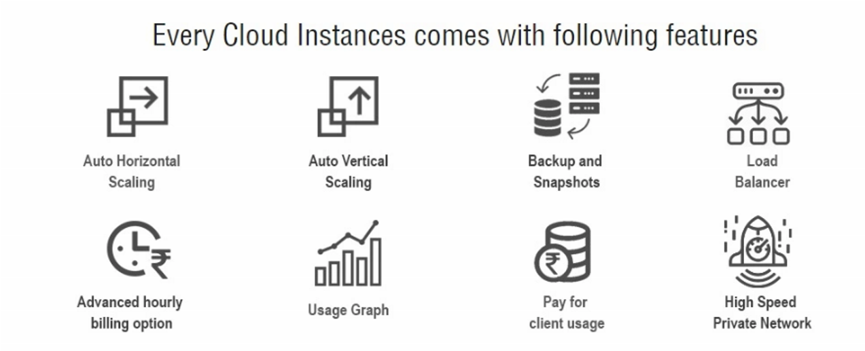

●

W

e

understand

your

needs

whether

you

are

a

small

business

owner

,

an

entrepreneur

,

a

beginner

, or a web developer

.

●

W

e

provide

free

domains

with

hosting

plans

to

encourage

our

customers

to

become

internet-enabled startups.

●

More than 200,000 websites are hosted with us in India.

●

This makes us the No-1 hosting provider in India.

**2**

**.**

**2**

**.**

**5**

**.**

**G**

**l**

**i**

**m**

**p**

**s**

**e**

**o**

**f**

**t**

**h**

**e**

**i**

**r**

**M**

**a**

**j**

**o**

**r**

**S**

**e**

**r**

**v**

**e**

**r**

**s**

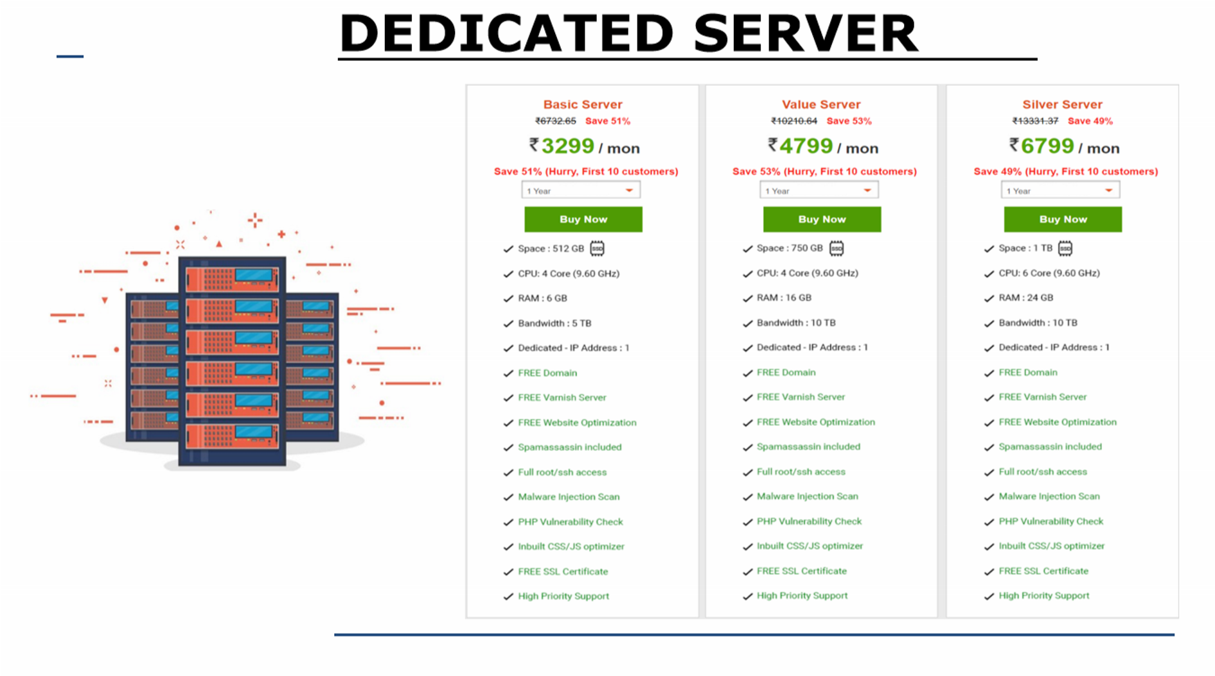

**2**

**.**

**2**

**.**

**6**

**.**

**W**

**h**

**a**

**t**

**’**

**s**

**N**

**e**

**w**

**?**

New hosting plan to the market from HostingRaja

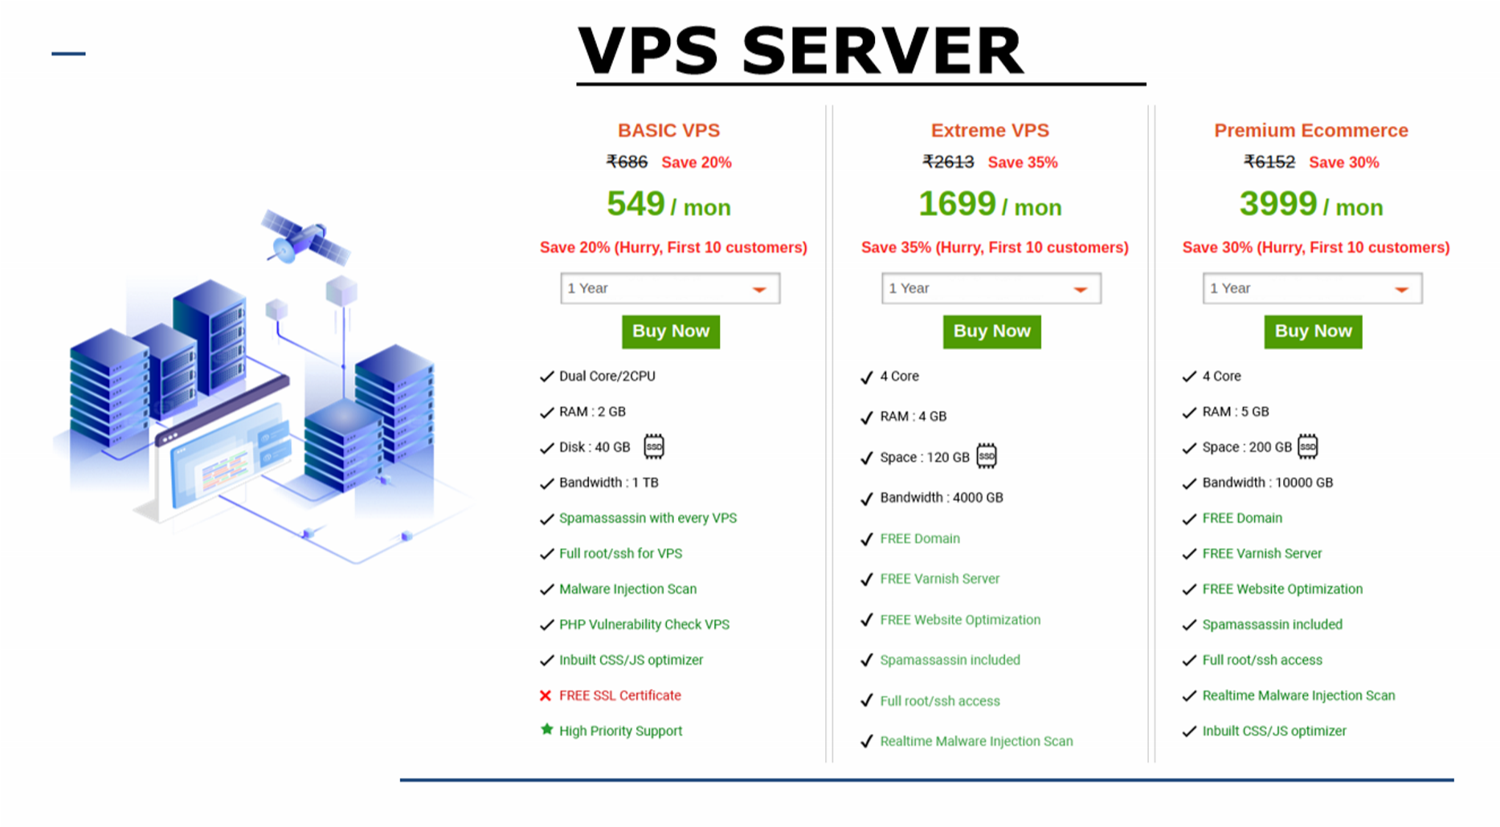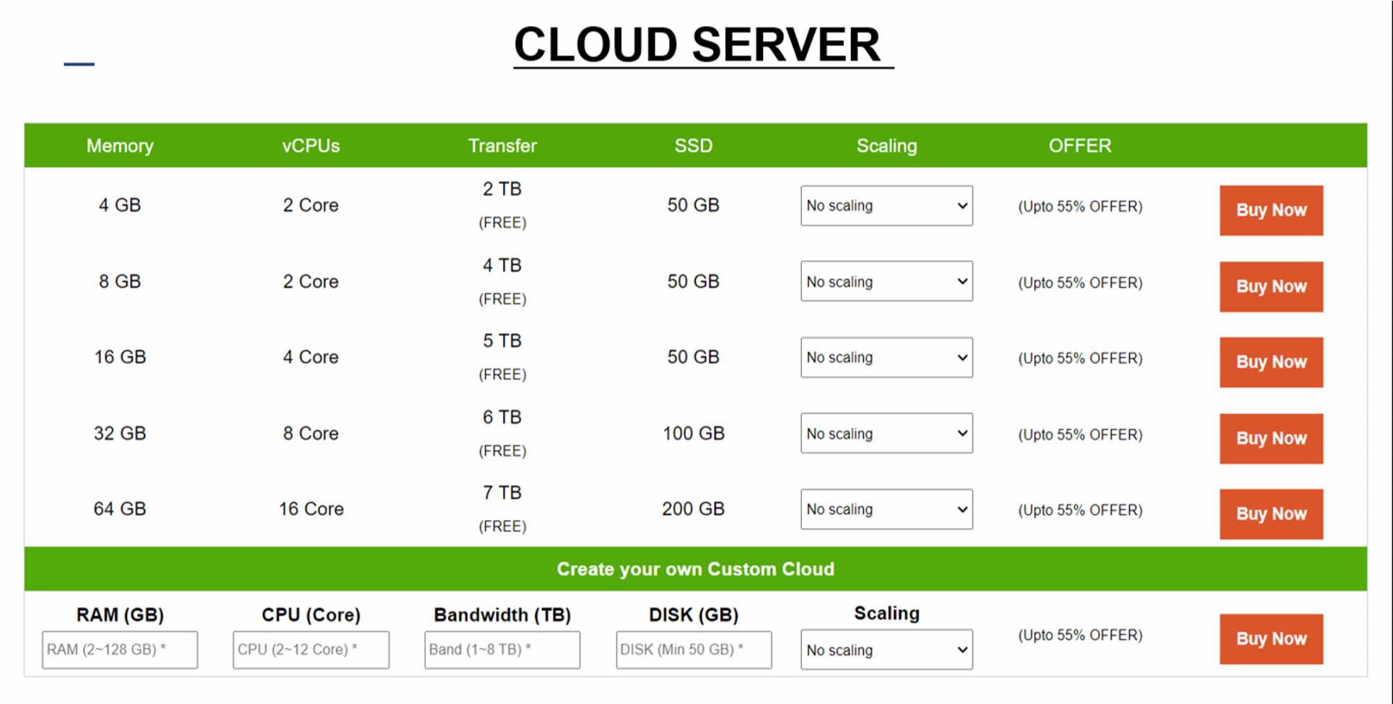

**Pr**

**emium**

**W**

**ebsite Hosting**

●

Premium SSD Unlimited

●

Speed - 2.5 seconds guarantee

●

LightSpeed Cache

●

Y

ou will get a High-Speed Network & Server

.

●

Speed Optimised Server

.

●

W

eekly Malware &

V

irus Clean.

●

3

Copies of backups.

**2**

**.**

**2**

**.**

**7**

**.**

**A**

**w**

**a**

**r**

**d**

**s**

**a**

**n**

**d**

**R**

**e**

**c**

**o**

**g**

**n**

**i**

**t**

**i**

**o**

**n**

**s**

●

T

op Pick

W

eb Hosts 2012 – Hosting Raja

●

GoDaddy Partner

A

ward – 2014 – HostingRaja

●

Business

Excellence

in

Domain

and

Hosting

Industry

-

Resellerclub

2010

and

2017

–

HostingRaja



**2**

**.**

**2**

**.**

**7**

**.**

**O**

**t**

**h**

**e**

**r**

**S**

**e**

**r**

**v**

**e**

**r**

**s**

**b**

**y**

**H**

**o**

**s**

**t**

**i**

**n**

**g**

**R**

**a**

**j**

**a**

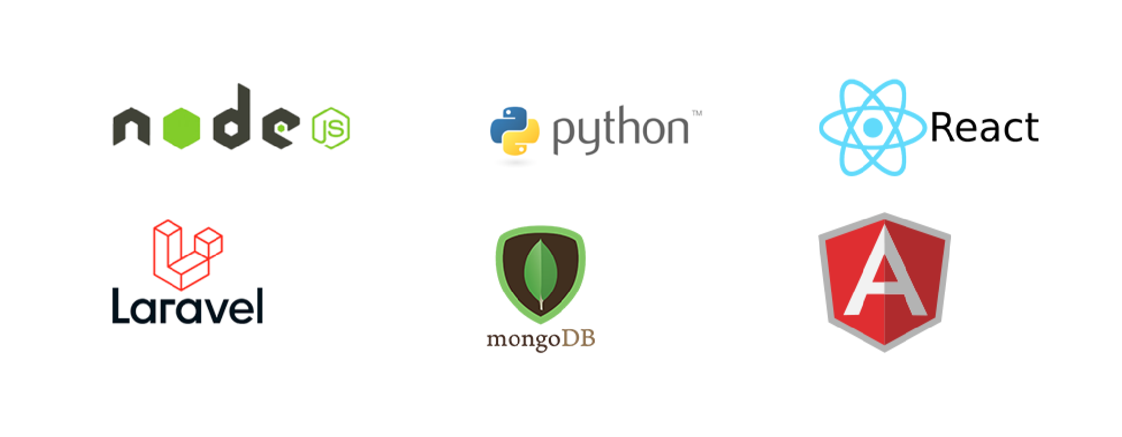

**2**

**.**

**2**

**.**

**8**

**.**

**O**

**u**

**r**

**C**

**l**

**i**

**e**

**n**

**t**

**s**

**2**

**.**

**2**

**.**

**9**

**.**

**M**

**a**

**n**

**a**

**g**

**e**

**d**

**I**

**T**

**S**

**o**

**l**

**u**

**t**

**i**

**o**

**n**

**s**

**.**

